LAB 3

Command Line Practice

program(1.txt) : this program is to find out the particular text from the given file name.

Example: below screenshot shows input and output of the program.

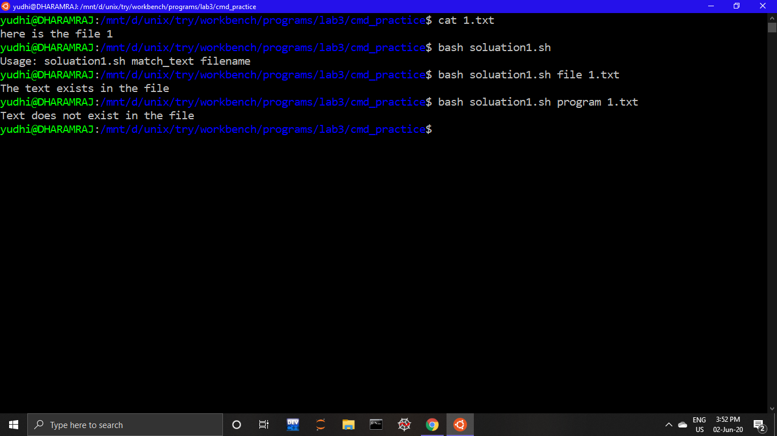

program(2.txt) : this program will count how many times a particular word is repeated in that particular file.

Example: below screenshot shows input and output of the program.

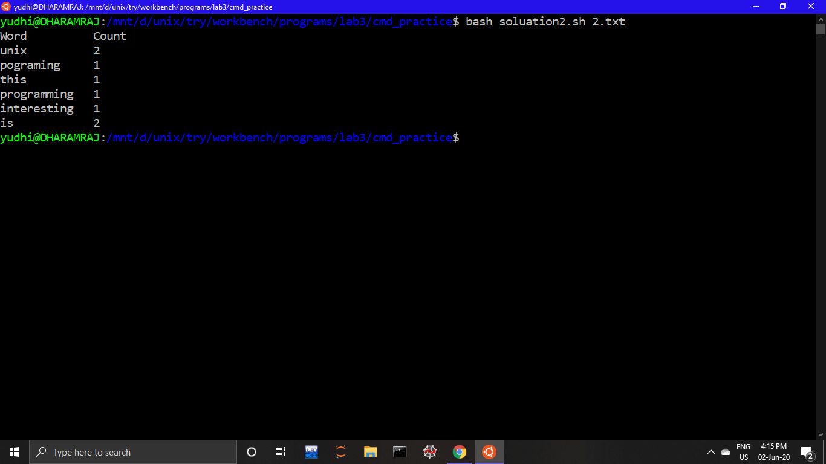

program(3.txt): This program takes all the unread messages from email and then displays the first 5 unread messages from our email.

Note: when I put my email id and the password in programs given variable.it did not displayed anything, it just skip the line.

But I got the mail regarding this…(screenshot)

And after allowing also it is showing same thing.

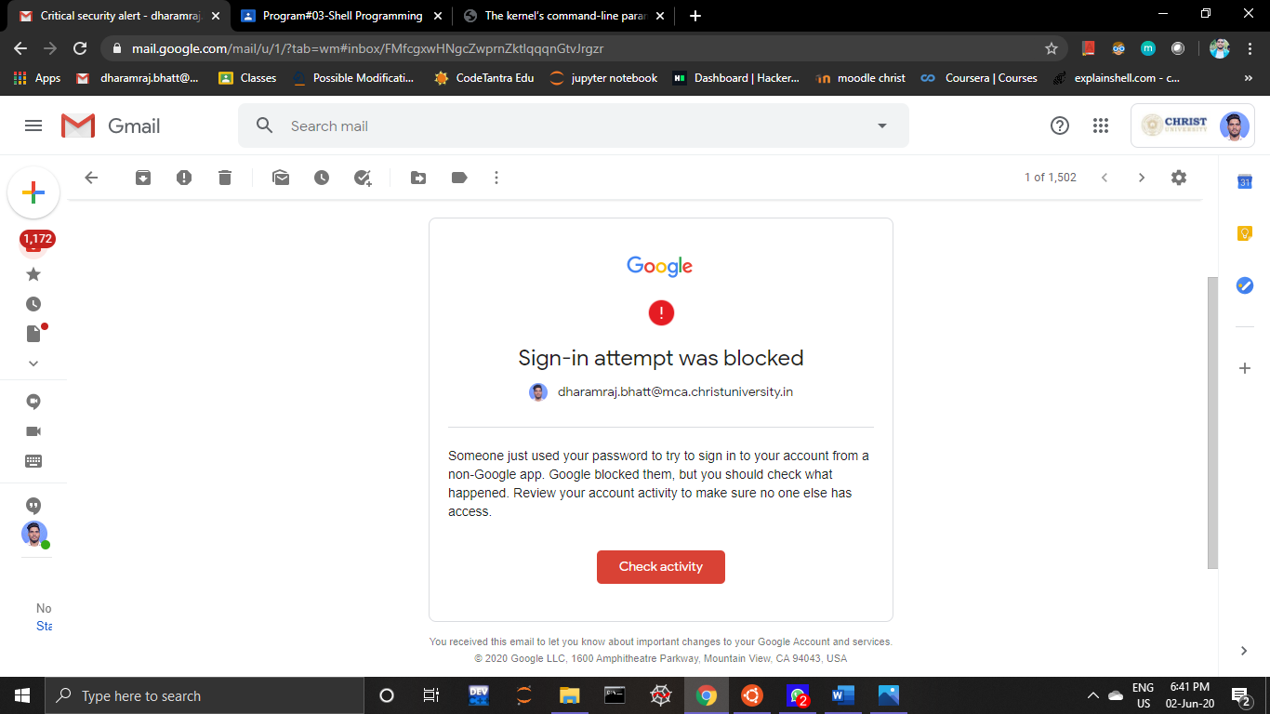

program(4.txt): This program downloads the images from a given website link and saves the image in the directory created by program itself(directory name will be )

It will takes three command line argument URL, -d, DIRECTORY name

Example: below screenshot(cmd) shows input and output of the program.

Note 1 :it creates directory with particular name and file containing image will be there (but in mine case it is showing we cant open file when I m trying to open that image).(2nd )

Note 2: I tried other web link of google but it was not working(may be because of the size of the link as a argument (not sure)).

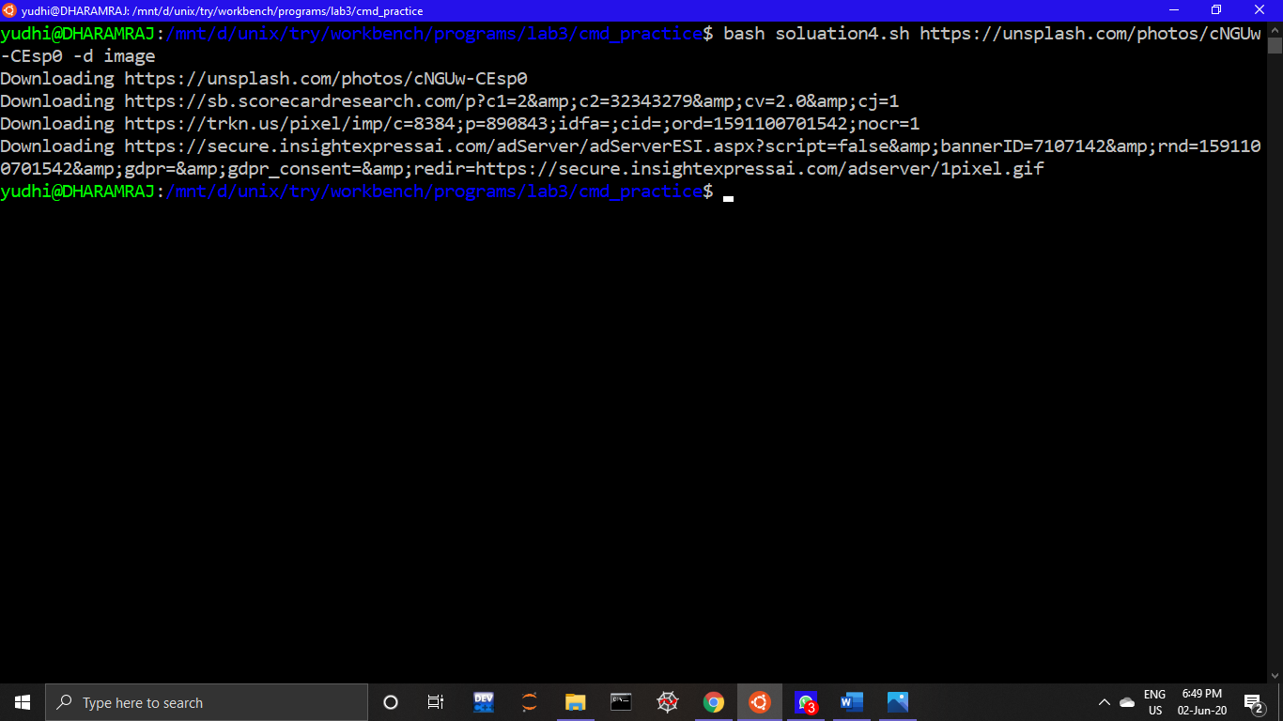

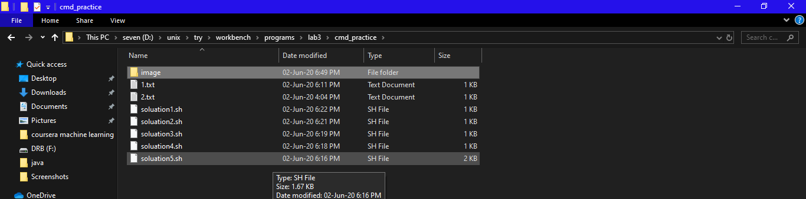

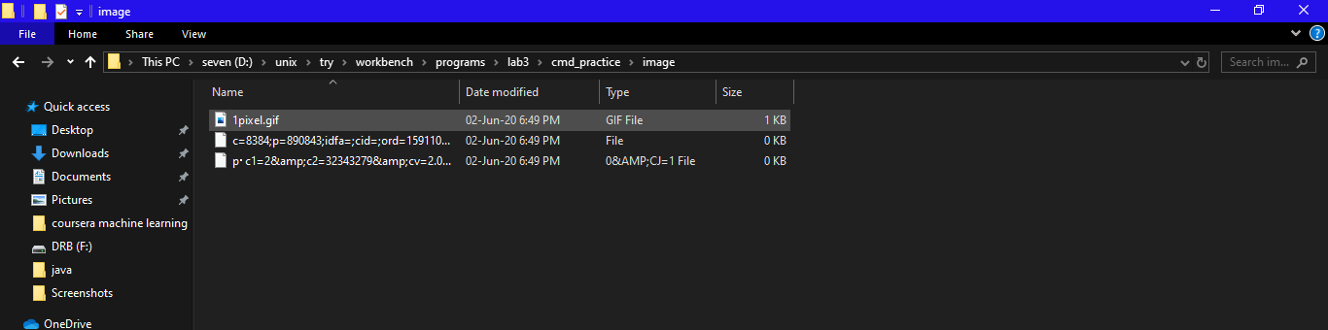

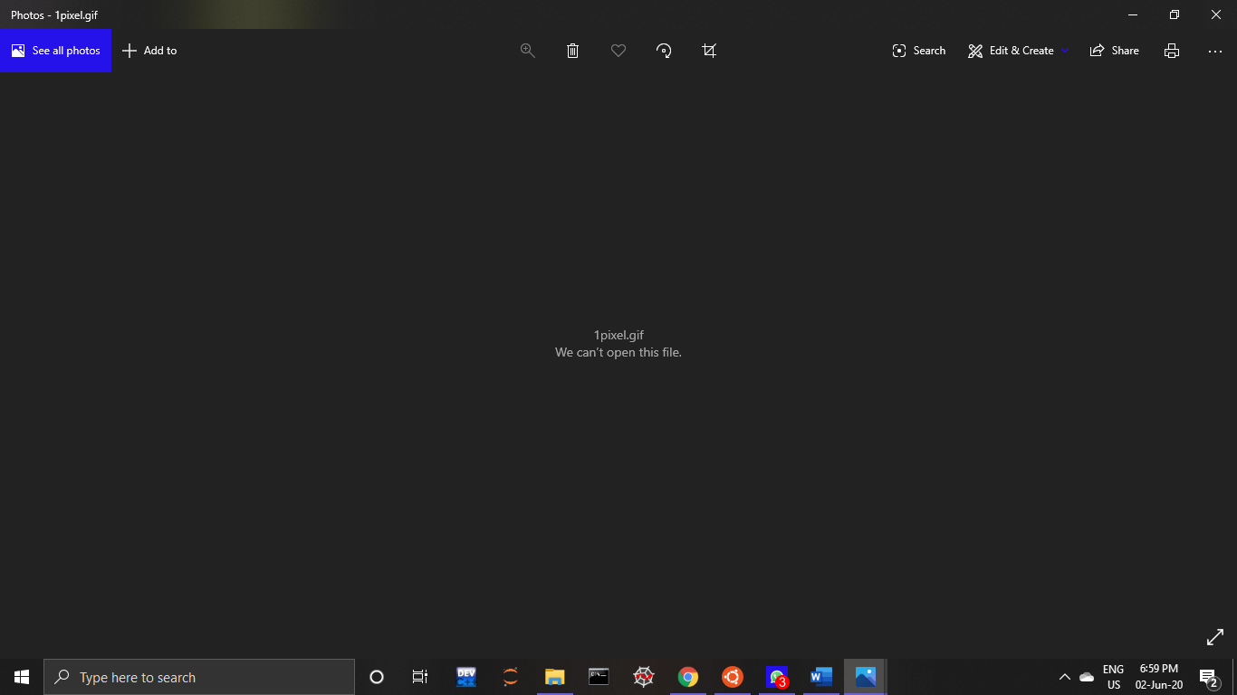

program(5.txt): This program takes multiple files as a cmd line input and then gives output of how many files are passed and in total how many total number of lines are there in all files.

Example: below screenshot shows input and output of the program.

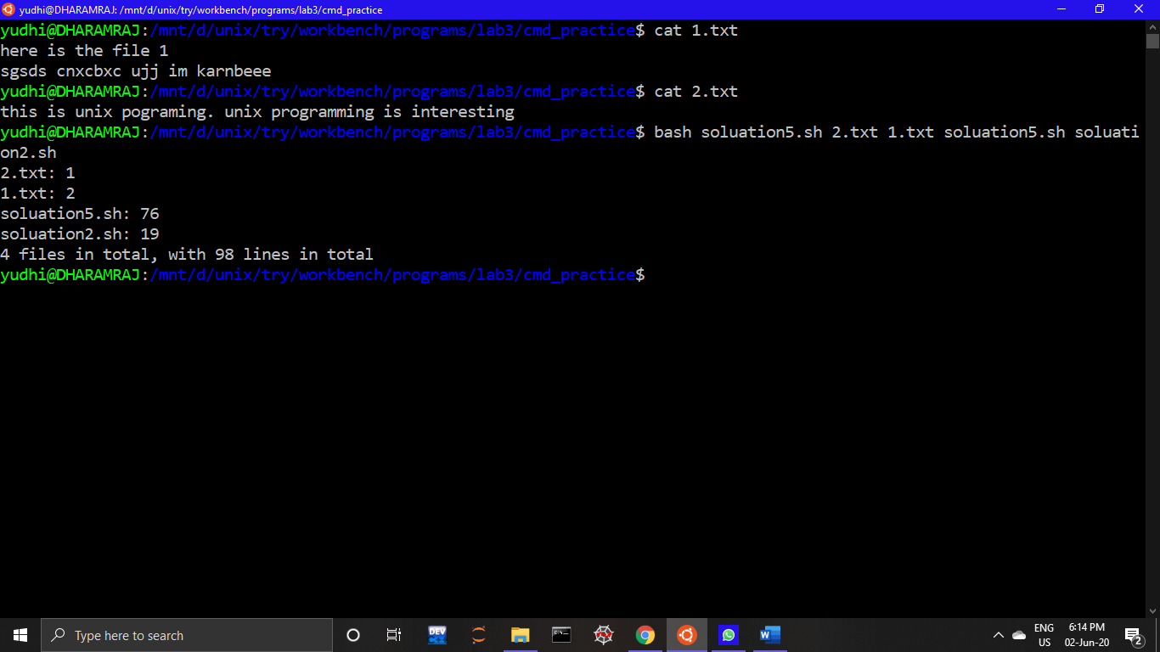

Shell Programs

1. Write Script to find out biggest number from given three nos. Nos are

input as command line argument. Print error if sufficient arguments are

not supplied.

Example: below screenshot shows input and output of the program2.sh.

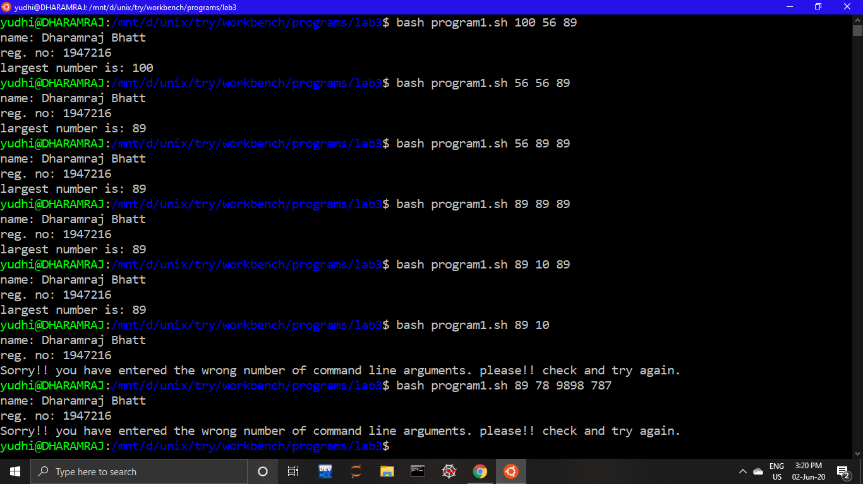

2. Write shell script using for loop to print the following patterns on screen.

Example: below screenshot shows input and output of the program2.sh.

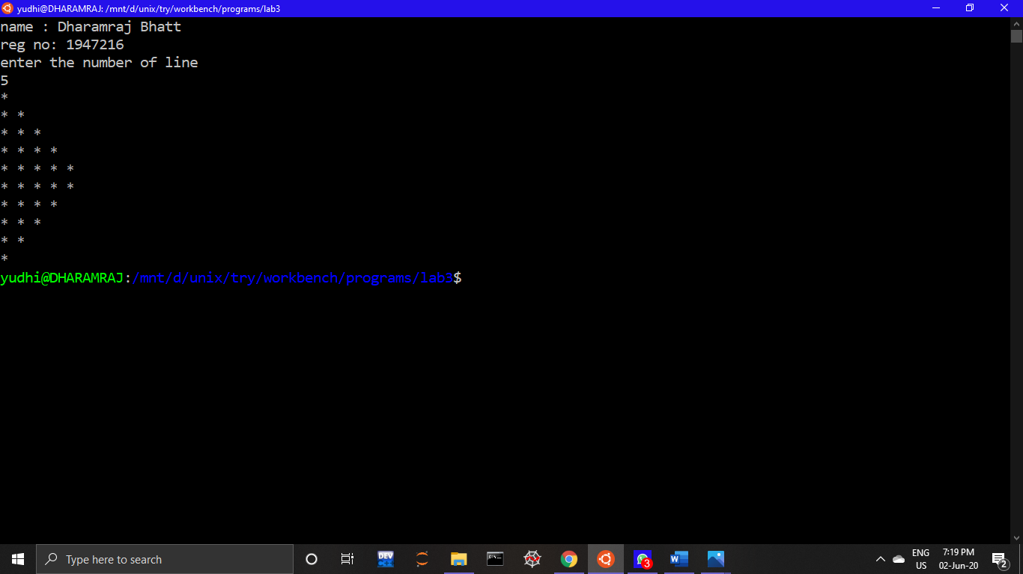

3. Write shell script using for loop to print the following patterns on screen.

Example: below screenshot shows input and output of the program3.sh.

